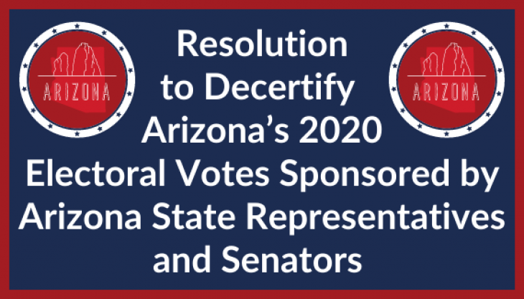

https://frankspeech.com/article/resolution-pull-down-arizonas-2020-presidential-electors

